**TITLE OF THE PROJECT**

## A PROJECT REPORT

***Submitted by,***

**Mr. XYZ - 20201CSE0123**

**Mr. ABC -20201CSE0124**

### *Under the guidance of,*

**Dr./Mr./Ms. IJKL**

***in partial fulfillment for the award of the degree of***

**BACHELOR OF TECHNOLOGY**

**IN**

**COMPUTER SCIENCE AND ENGINEERING, COMPUTER ENGINEERING, INFORMATION SCIENCE AND ENGINEERING Etc.**

**At**



**PRESIDENCY UNIVERSITY**

**BENGALURU**

**JANUARY 2024**

**PRESIDENCY UNIVERSITY**

**SCHOOL OF COMPUTER SCIENCE ENGINEERING & INFORMATION SCIENCE**

**CERTIFICATE**

This is to certify that the Project report **“TITLE OF THE PROJECT”** being submitted by “STUDENTS NAMES” bearing roll number(s) “STUDENTS ROLL NUMBERS” in partial fulfilment of requirement for the award of degree of Bachelor of Technology in Computer Science and Engineering is a bonafide work carried out under my supervision.

|  |  |
| --- | --- |
| **Dr/Mr/Ms. <SUPERVISOR NAME>**  DESIGNATION  School of CSE&IS  Presidency University | **Dr. <HoD Name>**  DESIGNATION & HoD  School of CSE&IS  Presidency University |

|  |  |  |
| --- | --- | --- |
| **Dr. C. KALAIARASAN**  Associate Dean  School of CSE&IS  Presidency University | **Dr. L. SHAKKEERA**  Associate Dean  School of CSE&IS  Presidency University | **Dr. SAMEERUDDIN KHAN** Dean  School of CSE&IS  Presidency University |

**PRESIDENCY UNIVERSITY**

**SCHOOL OF COMPUTER SCIENCE ENGINEERING & INFORMATION SCIENCE**

**DECLARATION**

We hereby declare that the work, which is being presented in the project report entitled **TITLE OF THE PROJECT** in partial fulfilment for the award of Degree of **Bachelor of Technology** in **Computer Science and Engineering**, is a record of our own investigations carried under the guidance of **SUPERVISOR NAME, DESIGNATION,** **School of Computer Science Engineering & Information Science, Presidency University, Bengaluru.**

We have not submitted the matter presented in this report anywhere for the award of any other Degree.

|  |  |
| --- | --- |
|  | **Name(s), Roll No(s) and Signature(s) of the Students** |

**ABSTRACT**

Video Surveillance involves the deployment of cameras, sensors, and other recording devices to capture data in real time at a particular location generating a large volume of visual data to supplement human capabilities. Video surveillance is a very potent tool used in the modern era to monitor people, goods, and services. It is often used in solving cases in all kinds of magnitude and helps in clearing names in cases of mishaps also. But this tool is very inefficient since it takes a lot of processing power to get proper results and the computing power is also on the upside. As this is the case, many researchers have branched out to figure out ways that would improve the efficiency of this process. Some concentrated areas are computer vision, machine learning, deep learning, neural networks, and algorithms. These approaches have enabled efficient research in this area leading to a lot of new discoveries and improvements. Traditional video surveillance uses a single camera setup to identify people. But this method is very inefficient. Multi camera setup does not have face recognition and detection features. To overcome these problems and find a bridge between them, improved algorithms have been created to assist with this process. The remarkable transformation and the evolution of video surveillance rudimentary closed-circuit systems has become the pillar of modern security and monitoring technologies.

**ACKNOWLEDGEMENT**

First of all, we indebted to the **GOD ALMIGHTY** for giving me an opportunity to excel in our efforts to complete this project on time.

We express our sincere thanks to our respected dean **Dr. Md. Sameeruddin Khan**, Dean, School of Computer Science Engineering & Information Science, Presidency University for getting us permission to undergo the project.

We record our heartfelt gratitude to our beloved Associate Deans **Dr. Kalaiarasan C and Dr. Shakkeera L,** School of Computer Science Engineering & Information Science, Presidency University and Dr. “NAME OF THE HOD”, Head of the Department, School of Computer Science Engineering & Information Science, Presidency University for rendering timely help for the successful completion of this project.

We are greatly indebted to our guide **Dr./Mr.Ms. Name, Designation**, School of Computer Science Engineering & Information Science, Presidency University for his/her inspirational guidance, and valuable suggestions and for providing us a chance to express our technical capabilities in every respect for the completion of the project work.

We would like to convey our gratitude and heartfelt thanks to the University Project-II Coordinators **Dr. Sanjeev P Kaulgud, Dr. Mrutyunjaya MS** and also the department Project Coordinators “NAME”.

We thank our family and friends for the strong support and inspiration they have provided us in bringing out this project.

**Name of the Student (1)**

**Name of the Student (2)**

**Name of the Student (3)**

**Name of the Student (4)**

**LIST OF TABLES**

|  |  |  |  |
| --- | --- | --- | --- |
| **Sl. No.** | **Table Name** | **Table Caption** | **Page No.** |
| 1 | Table 1.1 | Software modules versus Reusable components | 5 |

**LIST OF FIGURES**

|  |  |  |  |
| --- | --- | --- | --- |
| **Sl. No.** | **Figure Name** | **Caption** | **Page No.** |
| 1 | Figure 1.1 | Software modules versus Reusable components | 5 |

**TABLE OF CONTENTS**

|  |  |  |
| --- | --- | --- |
| **CHAPTER NO.** | **TITLE** | **PAGE NO.** |
|  | **ABSTRACT ACKNOWLEDGMENT**  **…** | **i**  **ii**  **…** |
| **1.** | **INTRODUCTION** | 1 |
|  | 1.1 GENERAL | 1 |
|  | 1.2 . . . . . . . . . . . . | 2 |
|  | 1.2.1 General | 5 |
|  | 1.2.2.1 General | 8 |
|  | 1.2.2.2 . . . . . . . . | 10 |
|  | 1.2.2 | 12 |
|  | 1.3 . . .. . . . . . .. . . . . . . | 13 |
|  | 1.4 . . . . . . . . . . . . . . . . | 15 |
| **2.** | **LITERATURE REVIEW** | **16** |
|  | 2.1 GENERAL | 17 |
|  | 2.2 . . . . .. | 19 |
|  | 2.2. | 20 |

**CHAPTER-1**

**INTRODUCTION**

Sentinel is a face detection, face recognition and multi-camera, real time surveillance system designed to use computer vision, deep learning, and machine learning techniques to ensure accurate face detection even under challenging conditions. By creating a comprehensive facial detection database, Sentinel will quickly identify the real time location and send alerts for seamless tracking and monitoring of individual across multi-camera setup rather than the use of conventional single camera face recognition capabilities. This will allow for the faster way of managing marginal resources. This

**CHAPTER-2**

**LITERATURE SURVEY**

**CHAPTER-3**

**RESEARCH GAPS OF EXISTING METHODS**

**CHAPTER-4**

**PROPOSED MOTHODOLOGY**

**CHAPTER-5**

**OBJECTIVES**

**CHAPTER-6**

**SYSTEM DESIGN & IMPLEMENTATION**

**CHAPTER-7**

**TIMELINE FOR EXECUTION OF PROJECT**

**(GANTT CHART)**

**CHAPTER-8**

**OUTCOMES**

**CHAPTER-10**

**CONCLUSION**

**REFERENCES**

**APPENDIX-A**

**PSUEDOCODE**

!yolo task=detect mode=train model=yolov8n.pt data={dataset.location}/data.yaml seed=14 epochs=250 imgsz=640 cos_lr=True optimizer='SGD' verbose=True  cache=True patience=50  single_cls=True amp=True batch=30 weight_decay=0.00075 warmup_epochs=2.5

!yolo task=detect mode=val model=/content/runs/detect/train/weights/best.pt data={dataset.location}/data.yaml plots=True

!yolo task=detect mode=predict model=/content/runs/detect/train/weights/best.pt conf=0.5 source={dataset.location}/test/images save_txt=true save_conf=true visualize=True augment=True

**APPENDIX-B**

**SCREENSHOTS**

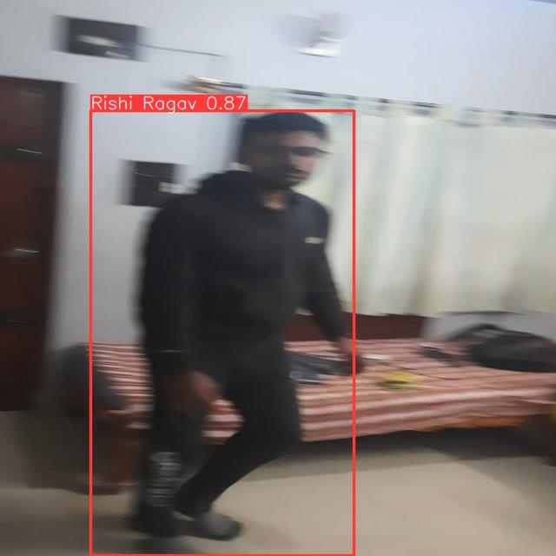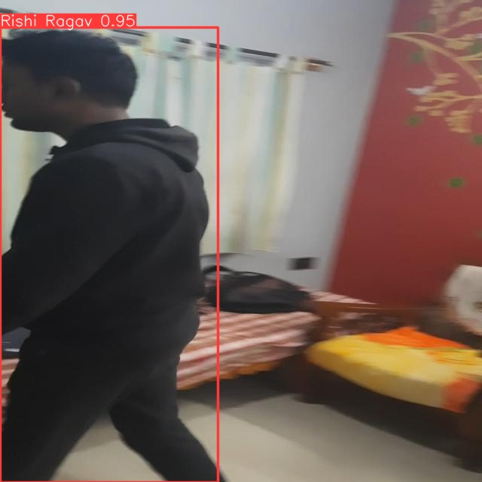

**APPENDIX-C**

**ENCLOSURES**

**1. Conference Paper Presented Certificates of all students.**

**2. Include certificate(s) of any Achievement/Award won in any project related event.**

**3. Similarity Index / Plagiarism Check report clearly showing the Percentage (%). No need of page-wise explanation.**